**ISO 9001:2015 CERTIFIED**

## M-Service Application Services Downtime Analysis

## Report

Process: Development and Maintenance

Department: TI&D – Integration and Digital Engineering

|  |  |  |
| --- | --- | --- |
| Prepared by: | Brian Okwayo |  |
| Reviewed by: | Kenny Mwatela |  |
| Date: | February 21 2022 |  |

1. **Background**

In accordance to Software Development best practice, the Integration and API Development unit of TI&D – Integrations & Digital Engineering have undertaken a System Analysis of the M-Service Application services on version 3.1.0

This activity was conducted on February 21, 2022 and It involved testing all the services within the application and their related Application Programming Interfaces (APIs). The Application services were distributed among the team of developers and manually testing the service end-to-end.

The following participated in the analysis process:

1. Kenny Mwatela
2. Andrew Kidula
3. Moses Nyonji
4. Brian Okwayo
5. Wycliff Muriithi
6. Abdirizak Kuno
7. Clinton Misango
8. **Findings**

The following was observed in the process of Analyzing M-Service services based on monthly statistics report. It was identified that some services in the application have zero usage in the months of January and February 2022 yet they have previously been working fine. The affected services include:

1. *PIN Creation*
2. *MRI Filing*
3. *MRI Property Registration*
4. *Tax Compliance Certificate Application*

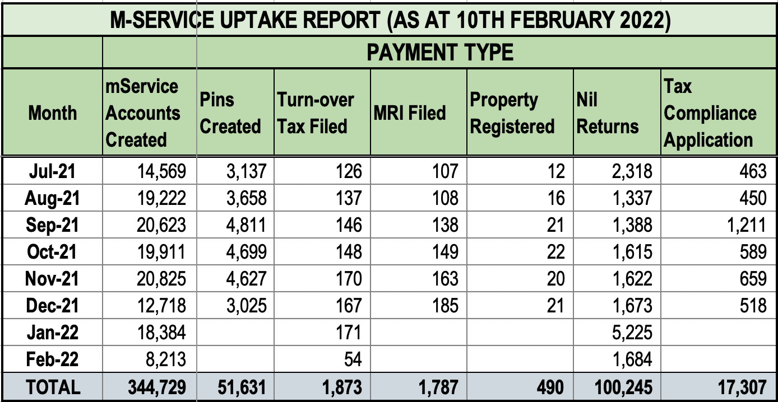

* 1. PIN creation in the application has an error emanating from the iTax API:

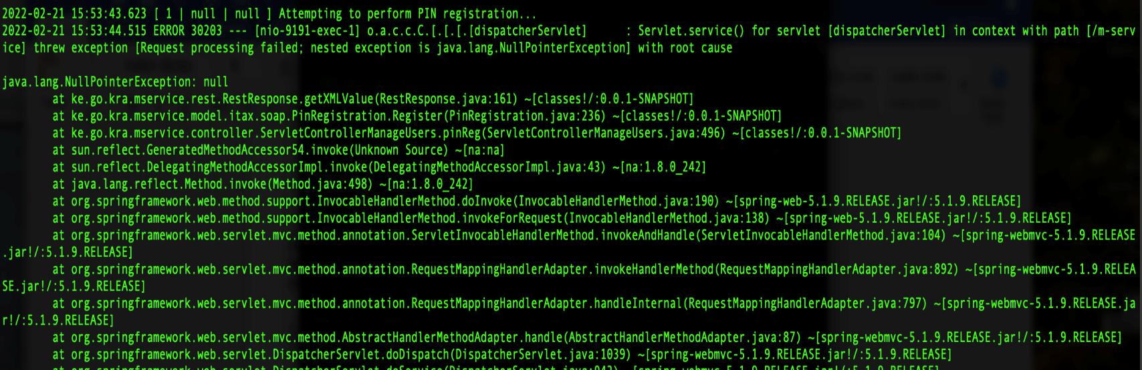

The error indicates that the process is not successful. This behavior is caused by an iTax upgrade in the beginning of the year. The upgrade had major changes in the PIN application process and the same is not updated in the API in use causing a conflict thus the error.

* 1. MRI filing service is also not working properly. When a user attempts to file a return, the MRI API responds with an ‘*Invalid User ID or Password’* error as indicated in the figure below.

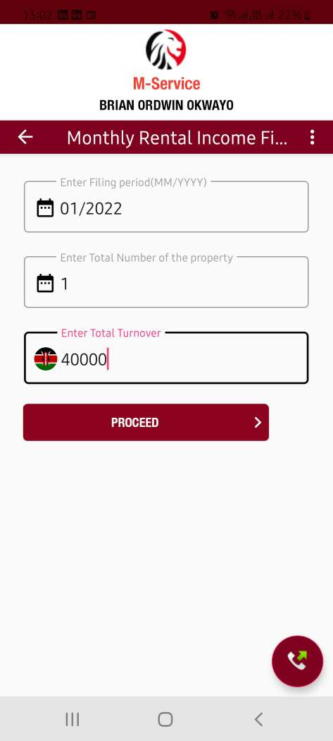 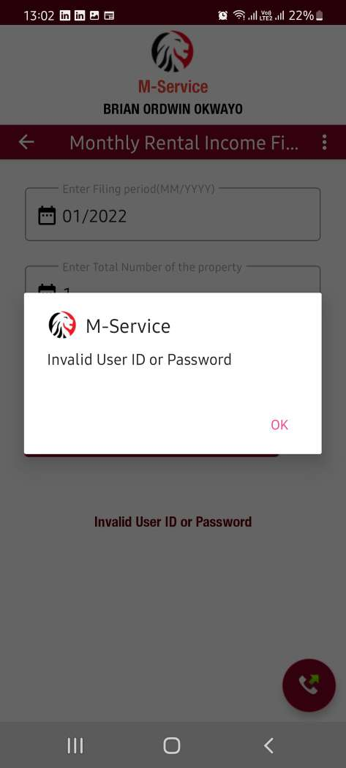

The backend system in turn logs the error:



The process of filing the return fails since the API cannot authenticate the request.

* 1. MRI property registration service is also not working. An attempt to register a property responds with an error code ‘89004’ (Invalid User ID or Password )from the application.

The process is not successful as the API cannot authenticate the request.



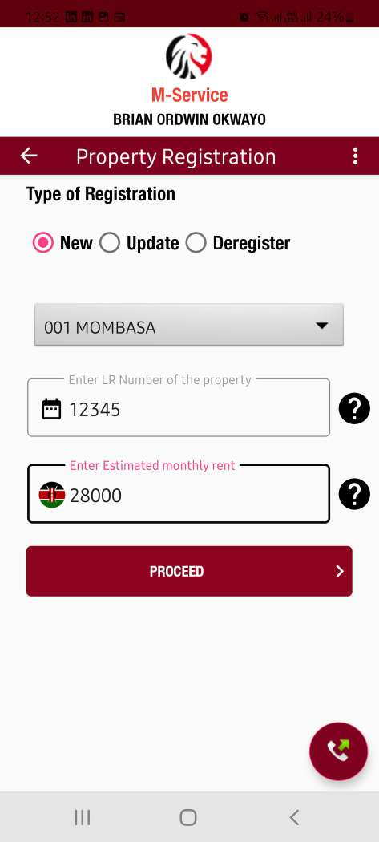 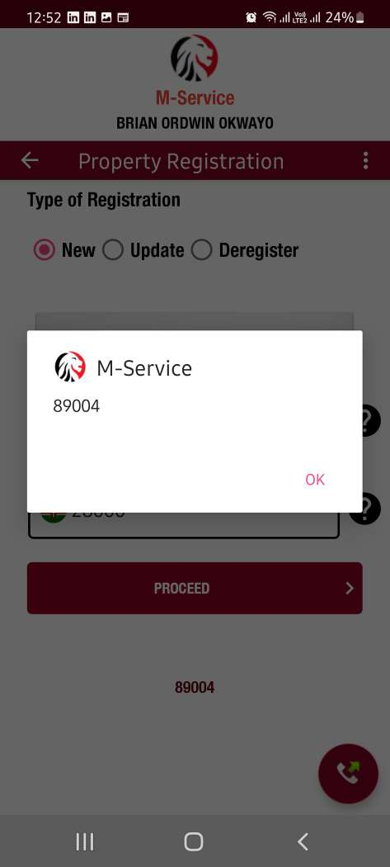

* 1. Tax Compliance application is also impossible with the current application. When a tax Compliance request is sent, the user gets a ‘Connection Error’ since the API is unreachable. Below is the screenshot of the error.

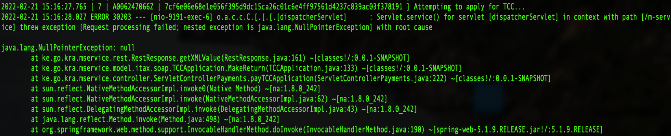

1. **Conclusions**
   1. From the analysis, the causative factors of services failure are the APIs in use. The iTax processes are getting an update yet the APIs are not. This causes an integration failure rendering these services unusable. The iTax APIs need to be reviewed and updated for the application’s consumption.
2. **Recommendations**
   1. ITax development team needs to document the updated services APIs that M-Service is using to avoid downtimes.